Part A — Practice Programs (Hour 1)
Work these in your lab-NN/ folder before the project: do the first one or two in the lab; the
last (For Advanced Learners) is for home.
1. Password strength (PasswordChecker.java + Driver.java)
(a) In PasswordChecker, check four rules — length ≥ 8, contains an uppercase letter,
contains a digit, contains a special character — using regex (e.g. “.*[A-Z].*”) or
String methods.
(b) Write strength(String pw) that counts how many rules pass and returns “Weak” (0–
1), “Medium” (2–3) or “Strong” (4).
(c) In Driver.main: test several passwords; for each, print which rules passed and the
final label.
Expected output: “abc” → Weak; “Abcd1234!” → Strong.

Driver.java code:
public class Driver {
public static void main(String[] args) {
PasswordChecker obj = new PasswordChecker();

String[] passwords = {
"abc",
"Abcd1234!",
"abcdefg1",
"ABCDEFGH"
};

for (String password : passwords) { //this means take every index password from "passwords" and give to "password " to check.
obj.checkRules(password);
}
}
}

PasswordChecker.java code:
public class PasswordChecker {

String strength(String pw) {
int count = 0;

if (pw.length() >= 8)
count++;

if (pw.matches(".*[A-Z].*"))
count++;

if (pw.matches(".*[0-9].*"))
count++;

if (pw.matches(".*[^a-zA-Z0-9].*"))
count++;

if (count <= 1)
return "Weak";
else if (count <= 3)
return "Medium";
else
return "Strong";
}

void checkRules(String pw) {
System.out.println("Password: " + pw);

if (pw.length() >= 8)
System.out.println("Length >= 8: Passed");
else
System.out.println("Length >= 8: Failed");

if (pw.matches(".*[A-Z].*"))
System.out.println("Uppercase letter: Passed");
else
System.out.println("Uppercase letter: Failed");

if (pw.matches(".*[0-9].*"))
System.out.println("Digit: Passed");
else
System.out.println("Digit: Failed");

if (pw.matches(".*[^a-zA-Z0-9].*"))//^ makes the statement that it does not contain any word or letter.
System.out.println("Special character: Passed");
else
System.out.println("Special character: Failed");

System.out.println("Strength: " + strength(pw));
System.out.println();
}
}
OUTPUT:
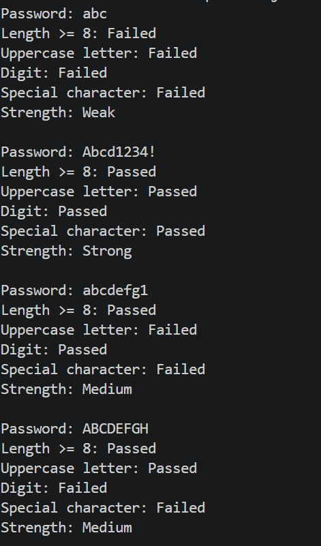

2. Chat-log filter (ChatFilter.java + Driver.java)
(a) In Driver.main, define a String[] of log lines like “10:05 alice Hello there” (include
one malformed line with fewer than 3 parts).
(b) Read a keyword from the user.
(c) For each line, split into time/user/message with split(“ ”, 3); skip lines that do not
have 3 parts.
(d) If the message contains the keyword (case-insensitive), increment a counter and
append “time user: message” to a StringBuilder.
(e) Print “Matches: N” and the built report.
Expected output: keyword “hello” over 3 lines (1 malformed) → “Matches: 1” and
the matching line.
Driver.java code:
import java.util.Scanner;
public class Driver {
public static void main(String[] args) {
String[] logs = {
"10:05 alice Hello there",
"10:10 bob How are you",
"10:15 Charlie"
};

Scanner sc = new Scanner(System.in);

System.out.print("Enter keyword: ");
String keyword = sc.nextLine();

ChatFilter obj = new ChatFilter();
obj.filter(logs, keyword);

sc.close();
}
}

ChatFilter.java code;
public class ChatFilter {
public String filter(String[] logs, String keyword) {
StringBuilder report = new StringBuilder();
int count = 0;

for (String line : logs) {
String[] parts = line.split(" ", 3);

if (parts.length < 3)
continue;

String time = parts[0];
String user = parts[1];
String message = parts[2];

if (message.toLowerCase().contains(keyword.toLowerCase())) {
count++;
report.append(time).append(" ")
.append(user).append(": ")
.append(message).append("\n");
}
}

System.out.println("Matches: " + count);
System.out.println(report);

return report.toString();
}
}
OUTPUT:
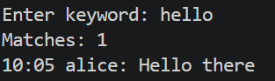
Key Questions / Analysis / Interpretation :

1. What is the difference between String, StringBuilder and StringBuffer?
- String: Immutable; its contents cannot be changed after creation.
- StringBuilder: Mutable and efficient for repeated string modifications; not thread-safe.
- StringBuffer: Mutable and synchronized, making its operations thread-safe.
2. What does the regular expression [6-9][0-9]{9} match, and why use anchors?
It matches a 10-digit number starting with a digit from 6 to 9. Anchors ^ and $ ensure the entire input matches the pattern, not just a part of it. For example, ^[6-9][0-9]{9}$.
3. Why should input be validated at the boundary before it is used?
Input validation catches invalid or unexpected data early. It improves security, prevents errors and ensures that only acceptable data reaches the application's logic.

